
Vedanta Zinc International | Procurement Transformation Programme

Initiative 13
End-to-End Spares Utilization
Tracking Optimization
Reservation-to-Consumption Traceability, Aging Intelligence and Exception-Based Accountability
Project | AI-Enabled Commercial Transformation Diagnostic & Opportunity Assessment
Prepared for | Vedanta Zinc International (VZI)
Prepared by | Zensar
Submission date | 31 August 2026

Table of Contents
1. Objective & Scope 3
Objective 3
Scope 3
2. Findings 3
2.1 As-Is Process Mapping 3
Current Platform Landscape 3
System Utilisation and User Adoption 3
Process Flow - Current State 4
2.2 Data Flows & Quality 4
Chain Linkage Assessment 4
Data Flow Assessment 4
Key Data Quality Risks 5
2.3 Integration Blueprint 5
Target Architecture Overview 5
Integration Points 5
Platform Architecture Layers 6
Initiation Demarcation 6
2.4 Challenges 6
2.5 Expectations 7
3. Solution Approach 7
3.1 Process Mapping for Change Readiness 7
Activities 7
Deliverables 7
3.2 Consumption Plan Capture & RR Enhancement 8
Objective 8
Approach 8
Deliverables 8
3.3 Reservation-to-Consumption Ledger & Aging Engine 8
Objective 8
Ledger Design 8
Aging & Exception Workflow 8
Deliverables 9
3.4 AI Intelligence & Redeployment Recommendations 9
Capabilities 9
Deliverable 9
3.5 Dashboards, Accountability, Analytics & Governance 9
Dashboard Suite 9
Access & Data Governance 9
4. Test Evaluation & Compatibility for Change Readiness 9
4.1 Pilot Design 9
Pilot Parameters 10
4.2 Test Scenarios 10
4.3 Compatibility Assessment 10
4.4 Change Readiness Evaluation Criteria 10
5. Benefits 10
5.1 Cost Savings 10
5.2 Process Efficiency 11
5.3 Compliance & Governance 11
5.4 Working Capital Optimisation 11
6. Conclusion 11
7. Disclaimer 11
8. Definitions 12

1. Objective & Scope

Objective
The goal is to create comprehensive traceability for the procurement and actual use of Order-as-Required (OAR) materials. This means that every reservation will include a consumption plan, each arrival will be linked to its intended use, and any unutilized stock will be identified and addressed before it becomes slow-moving or non-moving (NM/SM) inventory. This initiative enhances accountability for requesters, reduces the increase of NM/SM inventory, and transforms existing controls in VZI standard operating procedures into automated, exception-based workflows, all while maintaining human decision-making authority throughout the process.

Scope
This initiative addresses OAR materials at Black Mountain and Gamsberg and includes the following components:
- Capture of consumption plans during Request Requisition (RR) creation , facilitated by the AI-guided RR experience established under Initiative 9. This process requires mandatory user/project mapping, specification of the purpose, and provision of planned consumption dates for OAR requirements.
- A ledger that tracks the entire process from reservation to consumption, linking RR to Purchase Requisitions (PR), Purchase Orders (PO), goods receipts, and goods issues.
- An aging engine that includes alerts for planned consumption dates and a workflow for exception-based follow-ups, with escalations aligned to the existing Head of Department (HOD) approval hierarchy.
- Recommendations for pre-order duplicate demand and redeployment, utilizing the matching engine from Initiative 10.
- Dashboards for utilization, accountability, and net material/supply chain inflow, with role-based access controls.

2. Findings

2.1 As-Is Process Mapping

Current Platform Landscape
SAP ECC (on HANA) serves as the single system of record for managing reservations, purchase requisitions, purchase orders, goods receipts, and goods issues. User departments create reservations based on their needs engineering departments link them to job cards, while operations, safety, survey, IT, and other departments submit straightforward reservations. These reservations are then approved through a value-tiered Head of Department (HOD) hierarchy: HOD 1 can approve amounts up to R50,000; HOD 1 and 2 can approve up to R200,000; and HOD 1, 2, and 3 can approve amounts above R200,000.
Once a reservation is approved, stock availability determines the next steps: if stock is available, it is drawn directly from stores. If there is a shortfall, the procurement process begins according to the item's category. For materials categorized as OAR, a daily Material Requirements Planning (MRP) run generates a type-NB purchase requisition for the next calendar day, consolidating the total requirements for each material. The conversion from purchase requisition to purchase order follows the standard processes in Ariba and SAP and adheres to the applicable Delegation of Authority (DOA). Finally, goods receipts and goods issues are processed in stores against the approved reservation.
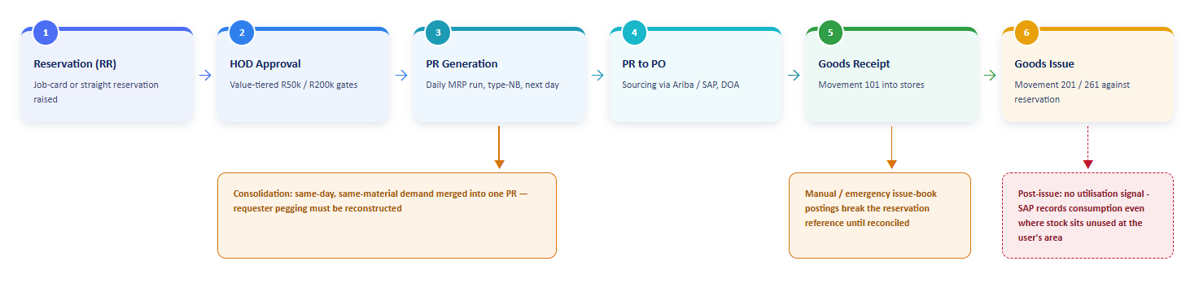
Figure 1: As-is reservation-to-consumption chain, with the visibility break points at consolidation, at manual issues, and beyond goods issue

System Utilisation and User Adoption
- Reservations serve as the entry point for all material demand, but the purpose and project context are only systematically captured for job-card-linked reservations. Straight reservations do not have any equipment, project, or job linkage.
- Warehouse controls are in place and actively enforced: a daily reservation report reviews long-outstanding reservations, the Standard Operating Procedure (SOP) requires issuance within 24 hours of the reservation when stock is available, materials flagged as SMI/NMI are blocked from purchase requisition creation under a transfer-first rule, and dormant codes (those without transactions for 24 months) are deactivated.
- However, these controls are largely manual and warehouse-driven, addressing issues late in the lifecycle after stock has already aged rather than at the moment demand is created or when goods arrive.
- Currently, no system provides answers to key questions for a given OAR arrival: who requested it, for what purpose, when it was planned to be consumed, and whether that consumption actually occurred.

Process Flow - Current State
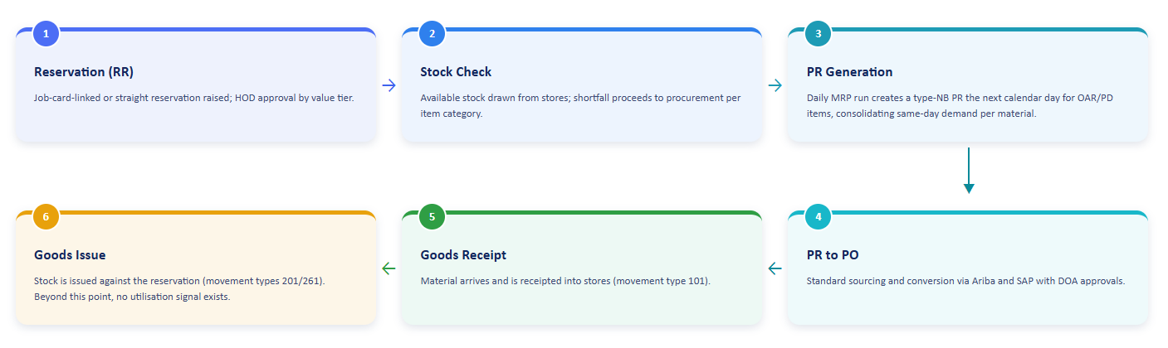
Figure 1: Process flow – Current State

2.2 Data Flows & Quality

Chain Linkage Assessment
The documentary process from demand to consumption is primarily established in standard SAP. This assessment highlights areas of strong linkage and those requiring reconstruction or supplementation.
Chain stage | SAP anchor | Linkage | Gap
Reservation header / line | RKPF / RESB (RSNUM + RSPOS) | Strong | Requester, department, requirement date and job/order link (where job-card-based) are natively captured; purpose is minimal or absent on straight reservations
Reservation to PR | RESB to EBAN | Conditional | The daily MRP run consolidates same-day, same-material, same-plant demand into a single NB PR; pegging must be reconstructed by allocation where lines collide
PR to PO | EBAN to EKPO | Strong | Hard-linked in standard SAP document references
PO to goods receipt | EKPO to MSEG / MKPF (101) | Strong | Hard-linked with PO reference
Goods issue to reservation | MSEG (RSNUM / RSPOS; 201 / 261) | Strong where used | Manual and emergency issues recorded via the offline issue book break the reference until the retrospective reservation is posted
Post-issue utilisation | None | Absent | Once issued, SAP records consumption; whether the material was physically used, installed, or stockpiled at the user’s area is invisible to the system

Data Flow Assessment
- Reservation to Procurement: Requirement dates and quantities are accurately transferred into MRP. However, the requirement date is often treated as an administrative field rather than a genuine, planned consumption commitment. This practice weakens its value as a baseline for aging analysis.
- Goods Receipt to Issue: The 24-hour issue rule means that most received OAR stock is quickly removed from stores. This shifts the utilization issue from a visible metric in SAP to an area not tracked in SAP.
- Consumption History: Movement history is reliable at the material level, but its fragmented connection to originating reservations limits accountability analysis at the requester and purpose levels.
- Reclassification Signals: Evidence of consumption frequency, which should trigger the reclassification of OAR to order-to-stock (more than four consumptions per year, as stipulated by the Inventory Management SOP), is currently not compiled systematically.

Key Data Quality Risks
- The existence of duplicate stock codes fragments both the consumption and utilization history for what is effectively the same part. This understates both demand and idle stock and reinforces Initiative 12 as a foundational prerequisite for the Spares suite.
- Reservations made without a specific purpose or project linkage hinder the process of attributing aged stock to an accountable owner or job.
- Transactions recorded offline or manually can temporarily disconnect goods movements from reservations, leading to erroneous "unconsumed" counts unless they are reconciled.
- The identification of OAR relies on the consistent maintenance of the material's planning category in the material master. If materials are miscategorized, they may fall outside the scope of the ledger. The exact fields and value sets will be confirmed during the initial data profiling.

2.3 Integration Blueprint

Target Architecture Overview
The utilization-tracking capability is being delivered as a module within the same AI platform being established under Initiatives 9 and 10, rather than as a separate system. It expands the platform in three key areas:
- Forward into demand capture by enforcing consumption plans in the AI-guided reservation and retrieval experience provided by Initiative 9.
- Inward by creating a reservation-to-consumption ledger within the platform’s Azure data layer.
- Outward through exception workflows facilitated by the platform’s shared notification service.
The platform interacts exclusively with SAP ECC through the SAP application layer, using OData services as the primary method and RFC/BAPIs as a backup, all accessed via API Management over HTTPS. There is no direct database access, and for this initiative, no write-back to SAP is required. All physical stock actions, such as issuing, transferring, and canceling reservations, will continue to be executed by authorized users via standard SAP transactions.
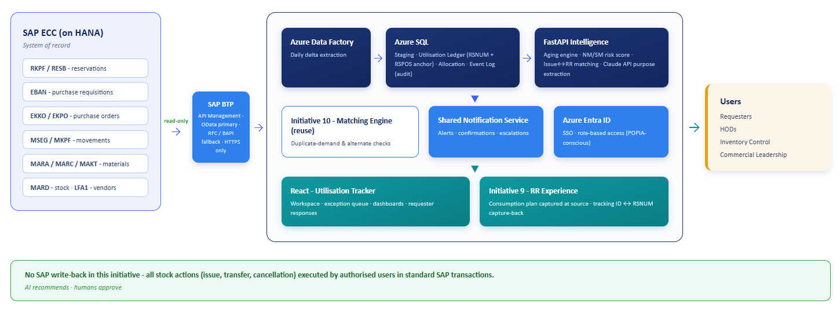
Figure 2: Target architecture - Initiative 13 as a module on the shared AI platform, read-only from SAP ECC through the application layer, reusing the Initiative 10 matching engine and the shared notification service.

Integration Points
System / source | Integration method | Direction | Data exchanged
SAP ECC (reservations & movements) | ADF via OData / RFC-BAPI through API Management | Inbound | RKPF/RESB reservations; EBAN PRs; EKKO/EKPO POs; MSEG/MKPF goods movements; MARA/MARC/MAKT material master incl. planning category and SMI/NMI status; MARD stock; LFA1 vendors
Initiative 9 RR experience (SharePoint form / platform UI) | Platform-native | Bi-directional | Consumption plan (planned consumption date, purpose, job/project/equipment linkage); platform tracking ID; SAP reservation number capture-back
Initiative 10 matching engine | Platform-internal API | Bi-directional | Duplicate-demand and approved-alternate lookups against the unused-stock ledger for redeployment recommendations
Azure Entra ID | OAuth 2.0 / SAML | Bi-directional | Requester identity, single sign-on, role-based access for dashboards and confirmations
Shared notification service | Platform notification engine / SMTP | Outbound | Aging alerts, confirmation requests, escalation notices, exception digests
Claude API (LLM) | REST API | Bi-directional | Purpose extraction from reservation and PR free text; natural-language ledger queries

Platform Architecture Layers
- Data Ingestion Layer (ADF): Scheduled pipelines extract the reservation and movement tables daily, using delta changes based on timestamps, from the SAP application layer into the platform's Azure SQL staging schema. This process extends, rather than duplicates, the shared extraction already serving Initiatives 9, 10, and 18. The primary additions are RKPF and RESB.
- Utilisation Ledger (Azure SQL): This layer features a data model anchored on reservation lines (with RSNUM and RSPOS as the key), including attributes such as requester, material, plant, quantities, dates, and job/cost object. It also includes an allocation table that reconciles consolidated purchase requisitions (PRs) to reservation lines, as well as an immutable event log that documents every lifecycle transition.
- Intelligence Layer (FastAPI, Claude API, Initiative 10 engine): This layer is responsible for aging computation, duplicate demand checks, risk scoring for NM/SM, probabilistic matching of issues to reservations, and extraction of purpose from free text.
- Workflow and Notification Layer: This includes the exception queue, requester confirmation flows, and escalation aligned with heads of department (HOD), all managed through a shared notification service.
- Presentation Layer (React): This consists of a Utilization Tracker workspace integrated into the existing platform front end, featuring consumption-plan fields embedded within the Initiative 9 Request Requisition (RR) experience.

Initiation Demarcation
Initiative | Owns | Relationship to Initiative 13
Initiative 9 | RR/PR creation experience and PR-to-PO cycle-time analytics | Initiative 13 extends the same RR form with consumption-plan fields - a single capture point, with no duplicate build
Initiative 10 | Alternate and substitute matching engine with tiered approval framework | Initiative 13 reuses the engine for pre-order duplicate-demand and redeployment checks against unused stock
Initiative 12 | Detection and prevention of duplicate stock codes (same physical part) | Foundational prerequisite: duplicate codes fragment the utilisation history this initiative depends on
Initiative 11 | SAP-native consumption-based planning for order-to-stock materials | Initiative 13 supplies systematic reclassification evidence (OAR materials consumed more than four times a year)
Initiative 7 | Predictive safety stock and reorder-point optimisation for stocked items | Clean boundary: Initiative 7 optimises planned stock; Initiative 13 tracks OAR accountability after demand is raised

2.4 Challenges
- There is a weak connection between procurement and utilization, leading to an increase in NM/SM inventory. Orders and end-user consumption are not consistently tracked, and unutilized OAR stock that has already arrived on site is not monitored.
- Once goods are issued as required by the SOP within 24 hours when stock is available SAP records consumption, even if the material remains unused in the user’s area. Consequently, the largest accountability gap lies beyond what SAP can track.
- Straight reservations lack any designation for purpose, project, or equipment, making it impossible to attribute aged stock to a specific accountable owner or job.
- Daily MRP consolidation, which merges same-day, same-material demand into a single PR, obscures individual requester attribution unless pegging is re-established.
- Existing controls (such as the daily reservation report, SMI/NMI PR block, and dormant-code deactivation) act too late and require manual intervention. By the time these controls trigger, working capital is already tied up in idle stock.
- Manual and emergency issue-book transactions disrupt the reservation reference until retrospectively reconciled.

2.5 Expectations
- Mandatory mapping of users and projects, along with a consumption plan for each OAR requirement and order. Planned consumption dates and their purposes should be recorded at the point of raising an RR or PR and enforced during the request process, rather than through SAP changes.
- Alerts for aging inventory should be sent once the planned consumption date arrives and the stock remains unutilized, with a simple confirm/re-plan/release response required from the requester.
- An exception-based follow-up process should be implemented for escalation, causing procurement and inventory control to engage only when requesters do not respond or when patterns of inactivity repeat.
- A complete audit trail should be maintained, detailing why each item was ordered, who committed to using it, when it was expected to be used, and what occurred after its arrival.
- Intelligent measures should be in place to prevent stock accumulation rather than merely reporting it. Before approving a new OAR demand, any identical, previously approved alternate stock that remains unused on-site or at other plants should be brought to attention.

3. Solution Approach
The solution completes the process that currently ends with goods issuance. It is structured into five workstreams:
- Preparing the organization for the updated process.
- Enforcing consumption plans at the point of demand.
- Integrating the reservation-to-consumption ledger with an aging engine.
- Applying preventive AI intelligence to the ledger.
- Presenting the results through exception-oriented dashboards governed by role-based access.
Every transition in the lifecycle is recorded in an immutable event log, ensuring that the audit trail is a natural outcome of the design rather than a separate deliverable.
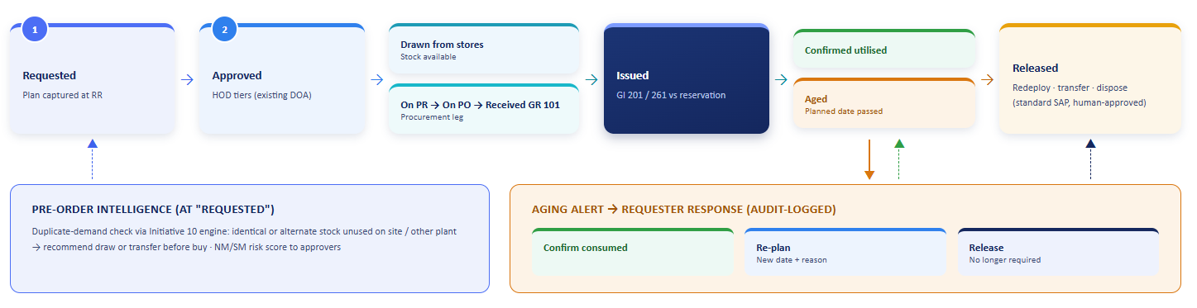
Figure 3: Utilisation lifecycle - from plan-backed request through fulfilment to confirmation, with the aging alert loop and pre-order intelligence. AI recommends; humans approve.

3.1 Process Mapping for Change Readiness
Objective
Map the ideal demand-to-consumption process and identify how the enforcement of consumption plans and exception workflows affects roles and handoffs for requesters, Heads of Department (HODs), warehouse personnel, and inventory control. Prepare the organization for successful adoption.

Activities
- To-be Process Design: Define each stage of the lifecycle (request, approval, fulfillment, receipt, issue, confirmation, aging, release). Specify the responsible role, the system of interaction, and differentiate between AI-generated recommendations and human decisions.
- Control Alignment: Map the initiative’s automated checks to the existing Standard Operating Procedure (SOP) controls they operationalize, including the 24-hour issue rule, daily reservation report, SMI/NMI transfer-first rule, and dormant-code rule. Position the change as a strengthening of current policies rather than the introduction of additional bureaucracy.
- Role-Specific Workflows: Define the confirmation duties for requesters, establish escalation touchpoints for HODs aligned with the existing value-tiered approval hierarchy, and outline exception handling for inventory controllers.
- Stakeholder Communication Plan: Keep leadership, plant management, HODs, warehouse teams, and end-users informed about progress, timelines, and expected benefits from the pilot phase through to full rollout.

Deliverables
- To-be process maps in swim-lane format, covering both reservation types and both plants.
- Control-alignment matrix mapping automated checks to existing SOP clauses.
- Communication and training plan.
3.2 Consumption Plan Capture & RR Enhancement

Objective

To ensure that every OAR (Order-as-Required) reservation is created with a complete and enforceable consumption plan, without relying on any changes to SAP or the SAP change-control pipeline.

Approach

- Form-Level Enforcement: The AI-guided Request Requisition (RR) experience introduced under Initiative 9 will include mandatory fields for the consumption plan of OAR items. These fields will include the planned consumption date, a narrative purpose, and the linkage to job, project, or equipment (which will be structural for job-card reservations and guided capture for direct reservations).
- Platform Tracking Identity: A unique tracking ID will be generated upon form submission. Once the SAP reservation is created, the associated reservation number will be linked to this tracking ID, ensuring a clear connection between the requester’s plan (and their Azure Entra ID) and the SAP document chain.
- AI-Guided Quality: The assistant will validate planned dates for reasonableness based on expected lead times, recommend job and equipment linkages based on historical patterns, and help draft the purpose narrative using the user’s own language.
- Requirement-Date Discipline: When preferred, the reservation requirement date will be set as the planned consumption commitment, with form validation ensuring that meaningful values are entered instead of administrative defaults.

Deliverables
- Extended RR form specifications that include consumption plan fields and validation rules.
- Design for capturing the tracking ID and related reservation number.
- Historical pattern suggestion model for linking jobs and equipment.

3.3 Reservation-to-Consumption Ledger & Aging Engine

Objective
To integrate the entire process from reservation to purchase requisition (PR), purchase order (PO), goods receipt, and goods issue into a comprehensive and queryable ledger. Additionally, we calculate the aging of each line item based on its planned consumption date.

Ledger Design
- Reservation-Line Anchor: Each reservation line (identified by RSNUM and RSPOS) serves as the ledger key. Key attributes include the requester, material, plant, quantities, requirements, planned consumption dates, and job or cost object. This structure allows for accountability roll-ups by user, department, material, and location.
- Fulfilment Legs: A reservation line can be satisfied by an immediate store issue, a procurement leg, or a combination of both (partial availability). The ledger is designed to accurately model both fulfillment legs, ensuring aging is calculated based on the correct quantities.
- Consolidation Allocation: In cases where the daily Material Requirements Planning (MRP) process combines same-day, same-material demands into a single PR, the PR quantity is allocated back to the reservation lines on a first-in-first-out basis, according to the requirement date. Lines allocated in this manner are marked as shared allocation rather than presented with misleading precision. A quantity reconciliation check ensures that the total of all allocations matches the PR quantity as part of ongoing integrity checks.
- Hard Links Elsewhere: The connections from PR to PO and from PO to receipt utilize standard SAP document references. Additionally, goods issues include a reservation reference that links these movements to their originating reservation.
- Event Log: Every stage of the process such as requested, approved, drawn, on-PR, on-PO, received, issued, confirmed, aged, re-planned, and released will be recorded in an immutable, timestamped event log, establishing a clear audit trail.

Aging & Exception Workflow
- Aging Trigger: A line ages when its planned consumption date has passed, and the received quantity has not been issued. In situations where the utilization-confirmation loop is applicable, a line will also age if it has been issued but not confirmed as used.
- Requester Response: The requester will receive an alert prompting three potential responses: Confirm Consumed, Delayed (requiring a new planned date and reason, which will be recorded in the audit trail), or No Longer Required (which releases the quantity as a candidate for redeployment).
- Escalation: If no response is received, the issue will escalate through the Head of Department (HOD) approval chain associated with the reservation, and ultimately to inventory control. Repeated aging cases from the same requester or department will be flagged as a pattern exception.
- Historical Stock: For stock items that predate the capture of planning, the aging will revert to the date of goods receipt, plus a grace period based on category, allowing for a prioritized assessment rather than neglecting backlogged items.

Deliverables
- Ledger data model and allocation specification with integrity checks
- Aging rule set and exception workflow design
- Event-log and audit schema

3.4 AI Intelligence & Redeployment Recommendations
To prevent idle stock creation and ensure a complete ledger even when document linkages break, we propose the following capabilities:

Capabilities

- Pre-Order Duplicate-Demand Check: When creating a Request for Restocking (RR), the Initiative 10 matching engine checks the unused stock ledger for the same material or an approved Tier 1 or Tier 2 alternative that is unconsumed at any plant. It then recommends either a store's draw or an inter-plant transfer before initiating a purchase order. This approach builds on the current SMI/NMI transfer-first control, now extending it to recently arrived stock that has not yet aged into those classifications.
- NM/SM Risk Scoring: Each new Order-as-Required (OAR) line is assessed for the likelihood of becoming unutilized, based on historical patterns related to material group, requester, department, site, and seasonality. High-risk requests are visibly flagged for approvers as part of the existing Delegation of Authority (DOA) process.
- Probabilistic Consumption Matching: Unreferenced goods issues including offline issue-book reconciliations are matched back to their originating reservations using signals from material, plant, quantity, date proximity, and requester information. This helps keep the ledger complete.
- Free-Text Purpose Mining: In cases where structured linkage is missing, particularly with legacy straight reservations and purchase request texts, are analyzed to infer purpose and potential job linkage, which will then be proposed for human confirmation.
- Governance: All recommendations are advisory in nature. Human operators will approve redeployments, confirm utilization, and execute all stock actions through standard SAP transactions. The AI system does not post directly to SAP.

Deliverable
- Integration specification for the duplicate demand check against the Initiative 10 engine.
- Feature definition and training approach for NM/SM risk scoring.
- Pipelines for issue-to-reservation matching and text mining, complete with review queues.

3.5 Dashboards, Accountability, Analytics & Governance
Provide inventory control, procurement, and leadership teams with a live, exception-oriented view of utilization health, with access regulated by role.

Dashboard Suite

- Unutilised OAR Position: Shows the value and count of unutilized stock by department, site, material group, and age bucket, with options to drill down to specific reservation lines and requesters.
- Plan Compliance: Displays the percentage of OAR reservations that have complete consumption plans, along with the on-time consumption rate compared to planned dates.
- NM/SM Inflow: Monitors the value of stock crossing aging thresholds each period this is the initiative’s key trend expected to decline as prevention and early intervention measures are implemented.
- Redeployment and Avoidance: Tracks purchases avoided through draw and transfer recommendations, along with value released through items determined to be no longer required.
- Reclassification Candidates: Identifies OAR materials that are consumed more than four times a year indicative of SOP reclassification opportunities which are proposed for conversion to order-to-stock and fed into the planning initiatives.

Access & Data Governance
Access is managed through Azure Entra ID single sign-on, with role-based scopes in place: requesters can view their own lines, Heads of Departments see their departments, and inventory control and commercial leadership have access to the full position. Personal data at the requester level is processed for legitimate operational accountability, with access restricted accordingly to comply with POPIA obligations.

4. Test Evaluation & Compatibility for Change Readiness

4.1 Pilot Design
The capability will first be tested on OAR materials at a single site before rolling out to both sites. A historical backfill of 24 months is proposed, aligned with the dormant-code window, to validate the ledger against known outcomes prior to live enforcement. This backfill will also measure the actual rate of same-day, same-material consolidation collisions, ensuring that allocation behavior is evidenced rather than assumed.

Pilot Parameters
- Site: The initial pilot will take place at both plants including both job-card-linked and direct reservations.
- Material Scope: The materials in scope will be OAR category materials, confirmed against the material master planning category during data profiling.
- Historical Backfill: The backfill will consist of 24 months of reservations, purchasing documents, and goods movements.
- Users: Participants will include requesters from two departments, warehouse and stores, inventory control, and HOD approvers.

4.2 Test Scenarios
# | Test scenario | What it validates | Success criteria
1 | One-to-one chain stitching | A reservation is traced RR to PR to PO to receipt to issue with correct quantities and dates | 98%+ of non-consolidated lines stitched automatically
2 | Consolidated PR allocation | Same-day, same-material reservations are allocated FIFO by requirement date; shared-allocation flag is set; quantities reconcile | 100% quantity reconciliation; collision rate quantified from the backfill
3 | Partial-availability split | A line with a stores draw plus a procurement leg is tracked on both legs | Correct leg-level aging on all test cases
4 | Aging alert and response | The alert fires on planned-date breach; confirm, re-plan and release paths each update the ledger and audit log | 100% of alerts fire on schedule; all three response paths complete end to end
5 | Escalation | Non-response escalates along the HOD chain per configured windows | 100% correct routing to the reservation’s own approval hierarchy
6 | Redeployment recommendation | A new RR for a material with unused identical or approved-alternate stock triggers a draw or transfer recommendation | Recommendation surfaced for 100% of seeded cases; approver decision captured
7 | Manual-issue reconciliation | Offline issue-book postings are matched back to originating reservations | 90%+ auto-match on the backfill sample; residual queued for human review

4.3 Compatibility Assessment
- Technical Compatibility: This involves the read-only extraction of reservation and movement tables through the SAP application layer while adhering to existing authorization patterns. We will confirm the specific fields and values that identify the OAR planning category during initial data profiling. Additionally, we will perform daily delta loads to handle transaction volumes at both plants.
- Process Compatibility: We will validate the locations of unutilized stock, focusing on whether it is in stores against open reservations or issued to user areas. This validation will help determine whether the requester utilization-confirmation loop can be implemented in the first release or postponed to a subsequent release. We aim to ensure smooth processing of urgent and breakdown demand.
- Organisational Compatibility: This includes the acceptance of requester confirmation responsibilities and escalation procedures for Heads of Departments (HODs). We will align alert routing with plant-level accountability and establish a common reconciliation practice across the warehouse teams of both plants.

4.4 Change Readiness Evaluation Criteria
- All test scenarios must successfully meet their criteria. The rate of consolidation collisions will be quantified, and the inventory control will accept the allocation approach.
- There should be no critical integration defects remaining unresolved.
- Feedback from requesters and HOD pilot tests will be incorporated, and leadership must approve the rollout plan for both sites.

5. Benefits

5.1 Cost Savings
- Avoided Purchases: The pre-order duplicate demand check directs demand to stock already available on-site or at a sister plant before any money is committed. This is the most direct way to reduce NMI/SMI inventory holdup.
- Reduced Write-Offs and Disposal Costs: Early intervention on aging stock preserves options for redeployment and return, which lapse once stock becomes obsolete.

5.2 Process Efficiency
- Exception-Based Control: Inventory control and procurement only engage when requesters fail to respond, or patterns repeat, eliminating the need for broad manual reviews of lengthy reservation reports.
- Automated Reclassification Evidence: Candidates for OAR-to-order-to-stock conversion are systematically generated, supporting planning improvements under Initiatives 11 and 7 without manual analysis.
- Faster Root Cause on Aged Stock: Any aged item can be resolved to its requester, purpose, and plan in a single query, rather than requiring a reconstruction across SAP transactions.

5.3 Compliance & Governance
- Complete Audit Trail: Every OAR requirement includes details about who requested it, why it was needed, when consumption was planned, and what occurred after arrival. This creates an immutable event log that material, requester, department, or date can search.
- Operationalised SOP Controls: The initiative automates and strengthens existing controls within the VZI policy such as reservation follow-up, transfer-first, and reclassification indicators rather than adding new parallel rules.
- Human Decision Authority Preserved: All recommendations are advisory; SAP postings remain with authorized users through standard transactions. Requester identity data is handled in accordance with POPIA.
- Migration Ready: The ledger uses standard SAP document references that carry forward, protecting investments during the future S/4HANA migration.

5.4 Working Capital Optimisation
- Lower NM/SM Inventory: Proactive measures during demand creation and early intervention for aging stock help to reduce the NM/SM inflow curve this is the initiative's primary benefit.
- Value Release from Idle Stock: Responses to no-longer-required stock convert silent inventory buildup into actionable decisions for redeployment, transfer, or disposal.
- Better Planning Inputs: Clean utilization data by requester and purpose improves the consumption baselines for planning initiatives.

6. Conclusion

The accountability gap that this initiative addresses is not a lack of data. The documentary chain from reservation to consumption is already established in the standard SAP; however, it is not integrated into a single ledger. We need to enforce a genuine consumption plan at the point of demand creation, along with a workflow that addresses aging stock while redeployment options remain available. Initiative 13 provides these three essential elements, delivered as a module on the shared AI platform created under Initiatives 9 and 10. This includes a single capture point in the Request Requisition (RR) experience, a reservation-line-anchored utilization ledger with an immutable audit trail, and an exception workflow that escalates within the approval hierarchy already used by VZI.
The design is intentionally built upon VZI’s existing control framework rather than around it. The daily reservation report, the transfer-first rule, and the reclassification indicators in the Standard Operating Procedures (SOPs) will become automated, front-loaded, and evidence-driven. Integration will be read-only through the SAP application layer, meaning no changes to SAP are required, and every AI output will serve as a recommendation for a human to act upon.
Within the Spares suite, this initiative aligns with a coherent progression: Initiative 12 establishes clean stock codes, Initiative 13 ensures accountable demand and utilization, and Initiatives 11 and 7 transform the resulting clean consumption evidence into better planning. The outcome is a reduction in non-movement (NM) and slow-moving (SM) inventory, achieved through prevention rather than periodic cleanup, along with an accountability record that can withstand audits.

7. Disclaimer
- Timeline: The implementation timeline of the initiatives finalized will be delivered as per the latest SOW.
- Benefits Delivered: The expected quantitative benefits will be delivered to Vedanta after pilot launch and the actual quantitative benefits will be shared after quarter usage of the live solution.
- Risks: The benefits delivered can be influenced by parameters that sit largely outside the initiative's control, including end-user adoption, data quality of the AI-guided creation flow and the associated learning curve, the accuracy and completeness of master data, and sufficient PR/PO volume in the observed month for the baseline to be statistically representative.
- Data Accuracy and Ownership: The responsibility for correcting data lies with Vedanta. Therefore, the benefits derived from this initiative can only be reliably measured once the necessary data clean-up and correction activities have been completed.
- Important: Data, privacy, and security for Models sold by Azure in Microsoft Foundry
        - Your prompts (inputs) and completions (outputs), your embeddings, and your training data:
        - are NOT available to other customers.
        - are NOT available to OpenAI or other providers of Models sold by Azure.
        - are NOT used by providers of Models sold by Azure to improve their models or services.
        - are NOT used to train any generative AI foundation models without your permission or instruction.
        - Customer Data, Prompts, and Completions are NOT used to improve Microsoft or third-party products or services without your explicit permission or instruction.
        - Your fine-tuned Models sold by Azure are available exclusively for your use.
- Access: Timely access to the following platforms is essential to proceed with the implementation roadmap and deliver the associated initiatives within the agreed timelines. Any delays in providing this access may impact on the scheduled delivery.
- SharePoint access is required to trigger and orchestrate workflows.
- Read access to the SAP Approval DOA mapping table, so approval routing in our workflows mirrors the DOA in SAP
- To progress solutioning and conduct solution walkthroughs with the VZI team, we request your approval for access to the SAP QA environment.
- SAP Application Layer: Access via OData, RFC, and BAPI should align with Vedanta’s established guidelines.
- OAuth 2.0 REST Endpoints: Access is needed for sourcing contract data.

8. Definitions

Abbreviation | Definition
ARC | Annual Rate Contract
BAdI | Business Add-In
BAPI | Business Application Programming Interface
BTP | Business Transformation Platform
CCO | Chief Commercial Officer
CEO | Chief Executive Officer
CFO | Chief Financial Officer
CM | Commercial Manager
CSR | Corporate Social Responsibility
DoA | Delegation of Authority
Entra ID | Cloud identity access manager
ERP | Enterprise Resource Planning
ESG | Environmental, Social and Governance
FIFO | First In First Out
FM | Financial Manager
FMI | Fast-Moving inventory
GRN | Good Receipt Note
HoD | Head of Department
HSE | Health, Safety and Environment
KPI | Key Performance Indicator
MIC | Metal in Concentrate
MIS | Management Information System
MRP | Material Requirement Planning
NFA | Note for Approval
NM/SM | Non-Moving/Slow-Moving
NMI | Non-Moving inventory
NRGP | Non-Returnable Gate Pass
OAR | Order-as-Required
OAuth | Open Standard Authorisation
OData | Open Data Protocol
OEM | Original Equipment Manufacturers
OPM | Original Part Manufacturers
PO | Purchase Order
POPIA | Protection of Personal Information Act.
PR | Purchase Requisition
QA | Quality Assurance
REST API | Representational State Transfer API
RFC | Remote Function Calls
RGP | Returnable Gate Pass
RR | Request Requisition
SMI | Slow-Moving inventory
SMTP | Simple Mail Transfer Protocol
SOP | Standard Operating Procedure
ULP | User Led Procurement
VZI | Vedanta Zinc International

